SECTION 06600
FIBERGLASS REINFORCED POLYMER (FRP) PRODUCTS AND FABRICATIONS

Table of Contents
PART 1: GENERAL
1.01 Related Documents ............................................................ 1
1.02 Summary ............................................................................. 1
1.03 Scope of Work .................................................................... 1
1.04 Quality Assurance ............................................................... 1
1.05 Design Criteria .................................................................... 3
1.06 Submittals ........................................................................... 3
1.07 Shipping and Storage Instructions ...................................... 3

PART 2: PRODUCTS
2.01 General ............................................................................... 4
2.02 FRP Pultruded Gratings and Treads .................................. 7
2.03 FRP Structural Shapes and Plate ....................................... 7
2.04 FRP Standard Railings...................................................... 10
2.05 FRP Ladders and Cages................................................... 12
2.06 FRP Foam Core Building Panels ...................................... 13
2.07 FRP Hollow Core Building Panels ..................................... 14
2.08 FRP Building Panel System .............................................. 16
2.09 FRP Planks ....................................................................... 17
2.10 FRP Baffle Wall Panel....................................................... 18
2.11 Molded Grating and Treads .............................................. 20

PART 3: EXECUTION
3.01 Preparation ....................................................................... 21
3.02 Inspection and Testing ...................................................... 22

GEF Incorporated
6497 Winfield Road
Winfield, WV 25213
(304)755-1600
www.gefinc.com
SECTION 06600
FIBERGLASS REINFORCED POLYMER (FRP) PRODUCTS AND FABRICATIONS

PART 1 – GENERAL

1.01 RELATED DOCUMENTS:

A. Drawings and general provisions of Contract, including General and Supplementary Conditions and Division-1 Specification Sections, apply to work of this section.

1.02 SUMMARY:

A. This section includes the following FRP Products & Fabrications:
1. FRP Pultruded Gratings and Treads
2. FRP Structural Shapes and Plate
3. FRP Standard Railings
4. FRP Ladders and Cages
5. FRP Foam Core Building Panels
6. FRP Hollow Core Building Panels
7. FRP Building Panel System
8. FRP Planks
9. FRP Baffle Wall Panels
10. Molded Gratings and Treads

1.03 SCOPE OF WORK:

A. Furnish all labor, materials, equipment and incidentals governed by this section necessary to install the fiberglass reinforced polymer (FRP) products as specified herein.

1.04 QUALITY ASSURANCE:

A. The material covered by these specifications shall be furnished by an ISO- 9001:2008 certified manufacturer of proven ability who is regularly engaged in the manufacture, fabrication and installation of FRP systems.

B. Substitution of any component or modification of system shall be made only when approved by the Architect or Design Engineer.

C. Fabricator Qualifications: Firm experienced in successfully producing FRP fabrications similar to that indicated for this project, with sufficient production capacity to produce required units without causing delay in the work.

D. In addition to requirements of these specifications, comply with manufacturer’s instructions and recommendations for work.

1.05 DESIGN CRITERIA:

A. The design of FRP products including connections shall be in accordance with governing building codes and standards as applicable.

B. Design live loads of FRP gratings and floor panels shall not be less than 100 PSF (4.79 kN/m) uniformly distributed unless specifically stated otherwise in drawings and/or supplementary conditions or in governing building code as applicable. Grating and floor panel deflection at the center of a simple span not to exceed 0.25” (6.4 mm).

C. Structural members shall be designed to support all applied loads. Deflection in any direction shall not be more than L/180 of span for structural members unless specifically stated otherwise in drawings and/or supplementary conditions. Connections shall be designed to transfer the loads.

D. Temperature exposure is limited to 100°F (38°C) unless specifically stated otherwise in drawings and/or supplementary conditions.

1.06 SUBMITTALS:

A. Shop drawings of all fabricated pultruded gratings and treads, structural shapes and plate, standard railings, ladders and cages, foam core building panels, building panel systems, planks, molded gratings and treads and appurtenances shall be submitted to the Design Engineer for approval in accordance with the requirements of Section ______. Fabrication shall not start until receipt of Design Engineer’s approval marked “Approved As Submitted” or “Approved As Noted”.
B. Manufacturer’s catalog data showing:
1. Materials of construction
2. Dimensions, spacings, and construction of grating, handrails and building panels.

C. Detail shop drawings showing:
1. Dimensions
2. Sectional assembly
3. Location and identification mark
4. Size and type of supporting frames required

D. Samples of each type of product shall be submitted for approval in accordance with the requirements of Section ______.

1.07 SHIPPING AND STORAGE INSTRUCTIONS:

A. All systems, sub-systems and structures shall be shop fabricated and assembled into

B. All materials and equipment necessary for the fabrication and installation of pultruded gratings and treads, structural shapes and plate, standard railings, ladders and cages, foam core building panels, building panel systems, planks, molded gratings and treads and appurtenances shall be stored before, during, and after shipment in a manner to prevent cracking, twisting, bending, breaking, chipping or damage of any kind to the materials or equipment, including damage due to over exposure to the sun. Any material which, in the opinion of the Design Engineer, has become damaged as to be unfit for use, shall be promptly removed from the site of work, and the Contractor shall receive no compensation for the damaged material or its removal.

C. Identify and match-mark all materials, items and fabrications for installation and field assembly.

PART 2 – PRODUCTS

2.01 GENERAL:

A. Materials used in the manufacture of the FRP products shall be raw materials in conformance with the specification and certified as meeting the manufacturer’s approved list of raw materials.

B. All raw materials shall be as specified by the contract.

C. The visual quality of the pultruded shapes shall conform to ASTM D4385.

D. With the exception of molded gratings and treads, all FRP products noted in 1.02 shall be manufactured using a pultruded process utilizing _________ (select polyester or vinyl ester) resin with flame retardant and ultraviolet (UV) inhibitor additives. A synthetic surface veil fabric shall encase the glass reinforcement. FRP shapes shall achieve a flame spread rating of 25 or less in accordance with ASTM test method E-84, the flammability characteristics of UL 94 V0 and the self- extinguishing requirements of ASTM D635. (Polyester resin is available without flame retardant and UV inhibitor additives.)

E. If required, after fabrication, all cut ends, holes and abrasions of FRP shapes shall be sealed with a compatible resin coating.

F. FRP products exposed to weather shall contain an ultraviolet inhibitor. Should additional ultraviolet protection be required, a one mil minimum UV coating can be applied.

G. All exposed surfaces shall be smooth and true to form, consistent with ASTM D4385.

H. Manufacturers:

1. Strongwell, Fabrication by GEF Incorporated (304)755-1600 www.gefinc.com

I. Pultruded FRP products shall be manufactured and fabricated in the USA. Manufacturer shall provide a written Certificate of Compliance.

J. The materials covered by these specifications shall be furnished by an ISO- 9001:2008 and ISO-14001 certified manufacturer.

PULTRUDED GRATINGS AND TREADS:

A. General

1. Grating shall be shipped from the manufacturer, palletized and banded with exposed edges protected to prevent damage in shipment.

2. Each piece shall be clearly marked showing manufacturer’s applicable drawing number.

3. Grating shall be DURADEK or DURAGRID as manufactured by Strongwell.

B. Design

1. The panels shall be _____ inches deep and sustain a deflection of no more than 0.25” (6.4 mm) under a uniform distributed load of 100 PSF (4.79 kN/m) for the span lengths shown on the plans. Refer to the Fiberglass Grating brochure at www.gefinc.com for a list of available sizes.

2. The bearing bars shall be joined into panels by passing continuous length fiberglass pultruded cross rods through the web of each bearing bar. A continuous fiberglass pultruded bar shaped section shall be wedged between the two cross rod spacers mechanically locking the notches in the cross rod spacers to the web of the bearing bars. Continuous adhesive bonding shall be achieved between the cross rod spacers and the bearing web and between the bar shaped wedge and the two cross rod spacers locking the entire panel together to give a panel that resists twist and prevents internal movement of the bearing bars.

3. Stair treads shall be capable of withstanding a uniform load of 100 PSF (4.79 kN/m) or a concentrated load of 300 lbs. (1.33kN) on an area of 4 sq. inches (2580.6 mm²) located in the center of the tread, whichever produces greater stress and deflect less than 0.25” (6.4 mm).

4. The top surface of all panels shall have a non-skid grit affixed to the surface by an epoxy resin followed by a top coat of epoxy resin.

5. Panels shall be fabricated to the sizes shown on the drawings.

6. Hold down clamps shall be type 316L stainless steel clips. Use 2 at each support with a minimum of 4 per panel.

7. Color shall be high visibility yellow.

-or-

Color shall be gray.

8. (Optional) All bearing bars that are to be exposed to UV shall be coated with polyurethane coating of a minimum thickness of 1 mil.

C. Products

1. The Pultruded FRP grating and stair treads shall be fabricated from bearing bars and cross rods manufactured by the pultrusion process. The glass fiber reinforcement for the bearing bars shall be a core of continuous glass strand rovings wrapped with continuous strand glass mat. A synthetic surface veil fabric shall encase the glass reinforcement.

2. Fiberglass Grating and Stair Treads

a) Fiberglass grating and stair treads shall be made from a chemical resistant, fire retardant _________ (select polyester or vinyl ester) resin system with antimony trioxide added to meet the flame spread rating of 25 or less in accordance with ASTM E-84 testing, the flammability characteristics of UL 94 V0 and satisfies the self- extinguishing requirements of ASTM D-635. UV inhibitors are added to the resin to reduce UV attack.

3. Grating with SAFPLATE®

a) Grating shall be the same as described above in this section.

b) SAFPLATE® shall be made from EXTREN® as distributed by GEF Incorporated.

c) SAFPLATE® shall be manufactured using an isophthalic polyester or vinyl ester resin with fire retardant additive to meet Class 1 flame spread rating of 25 or less as tested by ASTM E-84 and meet the self- extinguishing requirements of ASTM D-635. All plate shall contain a UV inhibitor.

d) SAFPLATE® shall be epoxy bonded to the grating, and a non-skid grit shall be affixed to the top surface of the assembly.

4. If required, all cut and machined edges, holes and abrasions shall be sealed with a resin or compatible coating with the resin matrix used in the bearing bars and cross rods.

5. All panels shall be fabricated to the sizes shown on the approved shop drawings.

2.02 FRP STRUCTURAL SHAPES AND PLATE:

A. Material

1. Structural shapes and plate shall be made from _________ (select isophthalic polyester or vinyl ester) resin with fire retardant additives to meet a flame spread rating of less than 25 per ASTM E-84, the flammability characteristics of UL 94 V0 and meet the self- extinguishing requirements of ASTM D-635. All structural shapes shall contain a UV inhibitor.

2. Pultruded profiles shall satisfy the visual requirements of ASTM D4385.

3. Structural shapes and plate shall be EXTREN as distributed by GEF Incorporated.

B. Process

- Manufactured by the pultrusion process.

2.03 Structural FRP members’ composition shall consist of a glass fiber reinforced polyester or vinyl ester resin matrix and glass reinforcements. A synthetic surface veil fabric shall encase the glass reinforcement. Glass strand rovings shall be used internally for longitudinal strength. Continuous strand glass mats or stitched
reinforcements shall be used internally for transverse strength.

3. Mechanical properties shall meet or exceed the values listed in Table 1.
Table 1 – Fiberglass Pultruded Material Properties
Minimum Ultimate Coupon Properties (UN)

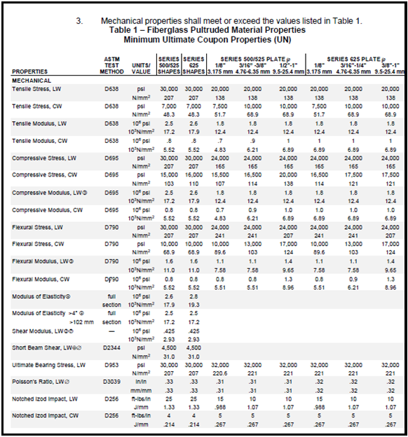

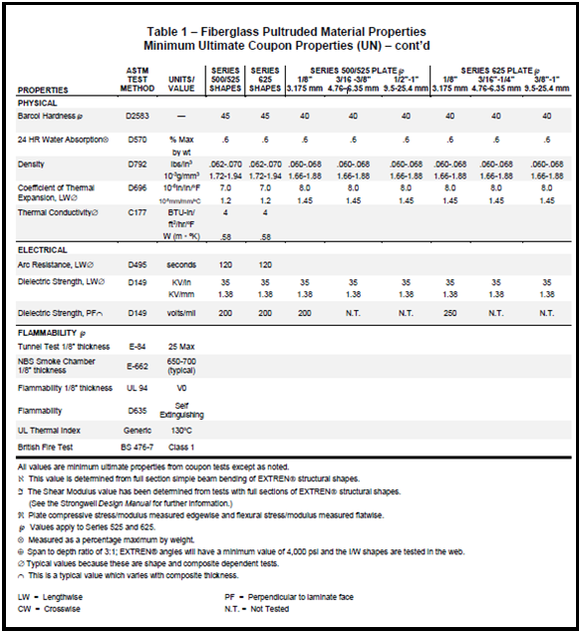

2.04 FRP STANDARD RAILINGS:
A. Design
1. The FRP standard railing system shall be designed to meet the configuration and loading requirements of OSHA, IBCO, or any governing building code as applicable, with a minimum factor of safety on loading of 2.0.

B. Material
1. The rails and posts shall be 2” (50.8 mm) x 2” (50.8 mm) x .156” (3.81 mm) square tube or 1.90” (48 mm) x 0.195” (5 mm) round tube manufactured by the pultrusion process. If pickets are required, they are to be a minimum of 1” square or round tube. The pultruded parts shall be made with a fire retardant resin that achieves a flame spread rating of 25 or less in accordance with ASTM test method E84, flammability characteristics of UL 94 V0 and meet the self- extinguishing requirement of ASTM D635. The resin matrix shall be ________ (select polyester or vinyl ester) and shall contain a UV inhibitor. The parts __________ (shall or shall not be) coated with an industrial grade polyurethane coating for additional UV protection and wear resistance. The color shall be chosen from manufacturer’s standard colors.

2. Mechanical properties shall meet or exceed the values listed in Table 2.

Table 2-Standard Railing Fiberglass Pultruded Material Properties
Minimum Ultimate Coupon Properties (UN)

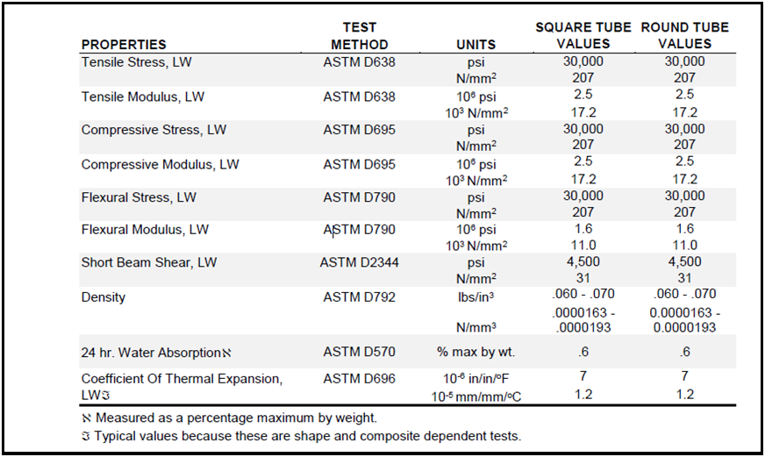
C. Fabrication of Standard Railing System

1. The fiberglass standard railing system shall be fabricated into finished sections by fabricating and joining together the pultruded square tube using molded or pultruded components; epoxy bonded and connected as shown in the fabrication details. Railing sections shall be fabricated to the size shown on the approved fabrication drawings and shall be piece marked with a water proof tag.

D. For Side Mount

1. Post shall be constructed with a pultruded bottom plug. Length shall be sufficient to extend a minimum of 1” (25.4 mm) beyond the uppermost bolt hole to prevent crushing of post tubing. Bolt holes shall provide clearance of 1/16” (1.59 mm) for 1/2” (12.7 mm) diameter bolts/studs. On square tubes, holes shall be on longitudinal center line of post, 1” (25.4 mm) from bottom of post (minimum) and not less than 3” (76.2 mm) apart on center. Posts shall be fastened with stainless steel anchor bolts or studs, 1/2” (12.7 mm) diameter.

2. Post locations shall be no greater than 18” (457 mm), nor less than 9” (229 mm) from horizontal or vertical change in handrail direction. For square tubes, post centers shall be no greater than 72” (1830 mm) apart on any straight run or rail, or 48” (1220 mm) apart on any inclined rail section.

E. Other Attachment Methods

1. Base mount, embedded and removable are also types of mounting procedures for railing pending design and approval by the Design Engineer.

F. Installation of Handrail Sections

1. The fabricated railing sections shall be supplied complete with fittings by GEF Incorporated. The components used to join fabricated sections together may be shipped loose, to be epoxied and riveted, if required, together, if required in the field by the contractor.

2. The fabricated handrail sections shall be installed as shown on the approved shop drawings. The handrail sections shall be accurately located, erected plumb and level. The sections shall be fastened to the structure as shown on the approved shop drawings.

G. Approved Fabricators

- GEF Incorporated (304)755-1600 www.gefinc.com
2.05 FRP LADDERS AND CAGES:
A. Performance Requirements

- Ladder and cage systems shall meet the requirements set forth in OSHA 1910.27.

B. Materials

1. The side rails and cage straps shall be fiberglass reinforced pultruded polyester with OSHA safety yellow pigment. As an option, an industrial grade polyurethane yellow coating may be applied to the finished ladder and cage. Other colors are available as an option.

2. The side rails shall be 2” (50.8mm) square tube with a wall thickness of .156” (3.81mm) or greater. The rungs shall be pultruded 1.25” (31.8mm) diameter FRP fluted tube.

3. Cage hoops shall be manufactured by the open mold hand lay-up process with a width of 3” (7.62mm) and thickness of 1/4” (6.4mm) minimum at the top and bottom and 2” (50.8mm) x 1/4” (6.4mm) at the intermediate hoops. The cage shall be interconnected with 2” X 9/16” X 1/8” pultruded channel straps spaced 9” (229mm) on center around the hoop.

4. Fiberglass pultruded rails, cage straps, fluted tube and cage hoops to be fabricated by GEF Incorporated.

C. Fabrication Requirements

1. If required, all joints and rungs shall be epoxied and riveted. The hoops shall be attached to the rails in a manner which provides hand clearance throughout the length of the ladder.

2. Ladders shall be shop assembled, and as an option may be pre-drilled and prepared for field attachments of standoff clips.

3. The ladder cages shall be shipped assembled or as an option may be shipped unassembled for field assembly using rivets or bolts.

D. Workmanship

1. If required, all cut or machined edges, holes and abrasions shall be sealed with a resin compatible with the resin matrix used in the structural shape.

E. Approved Fabricators

1. GEF Incorporated (304)755-1600 www.gefinc.com
F. Installation
1. All FRP ladder sections shall be installed as shown on the approved shop drawings.
2.06 FRP FOAM CORE BUILDING PANELS:
A. Materials
1. Each panel shall be manufactured using a pultruded process utilizing ________ (select isophthalic polyester or vinyl ester) resin with flame retardant and UV inhibitor additives. A synthetic surface veil shall be the outermost layer covering the exterior surface. The FRP panel shall achieve a flame spread rating of 25 or less in accordance with ASTM test method E-84. Each panel will consist of an outer pultruded FRP skin with a rigid foam core having an approximate “R” factor of 7 per inch of panel thickness.
2. Exposed foam core panel ends as an option may be encapsulated with FRP pultruded materials. If required, the ends of the panels must be encapsulated or coated with a resin similar to the skin resin to maintain the corrosion and weather resistant qualities of the total panel.
3. Mechanical and physical properties shall meet or exceed the values listed in Table 3.

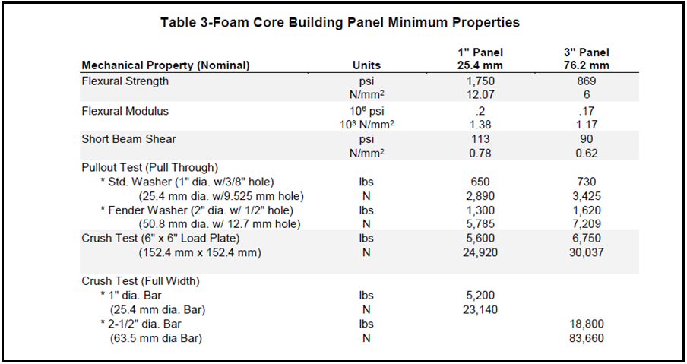
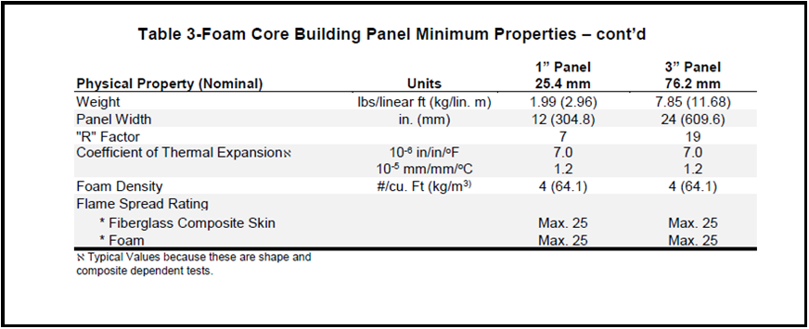

4. Fiberglass pultruded foam core DURASHIELD panels are to be fabricated and distributed by GEF Incorporated.
B. Connections
1. Panels will be designed for tongue-in-groove joint connections on two parallel sides per panel.
2. The panels are to be fastened to the super structure with stainless steel or fiberglass fasteners as shown on the approved shop drawings.
C. Approved Fabricators
1. GEF Incorporated (304)755-1600 www.gefinc.com
2.07 FRP HOLLOW CORE BUILDING PANELS
A. Materials
1. Each panel shall be manufactured by the pultrusion process utilizing _____________ (select isophthalic polyester or vinyl ester) resin with flame retardant and UV inhibitor additives. A synthetic surfacing veil shall be an outermost layer covering the exterior surface. The FRP panel shall achieve a flame spread rating of 25 or less with ASTM E- 84 test method, flammability characteristics of UL 94 V0 and self- extinguishing requirements of ASTM D635.
2. Mechanical and physical properties shall meet or exceed the values listed in Table 4.
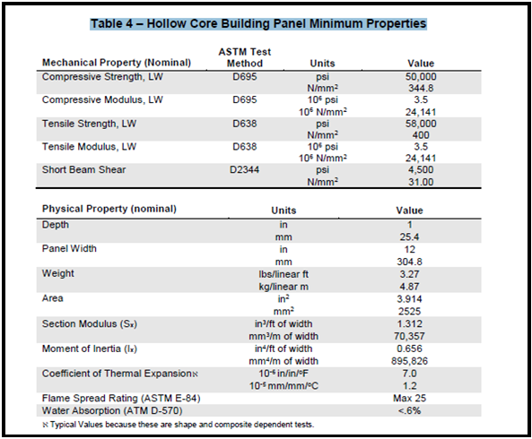
3. Fiberglass hollow core panels shall be DURASHIELD HC® as fabricated and distributed by GEF Incorporated.
B. Connections
1. Panels will be designed for tongue-in-groove joint connections on two parallel sides per panel.
2. The panels are to be fastened to the super structure with epoxy adhesive and/or stainless steel or fiberglass fasteners as shown on the approved shop drawings.
C. Approved Fabricators
1. GEF Incorporated (304)755-1600

2.08 FRP BUILDING PANEL SYSTEM
A. Materials
1. Each panel shall be manufactured by the pultrusion process utilizing _________ (select isophthalic polyester or vinyl ester) resin with flame retardant and UV inhibitor additives. A synthetic surface veil shall be the outermost layer covering the exterior surface. The FRP panel shall achieve a flame spread rating of 25 or less in accordance with ASTM test method E-84, flammability characteristics of UL 94 V0 and meet the self-extinguishing requirements of ASTM D635.
2. The 3-way connector, hanger, 45º connector, toggle connector and end cap required to install the building panel system shall be manufactured by the pultrusion process, and achieve a flame spread rating of 25 or less in accordance with ASTM test method E-84.
3. The following minimum mechanical properties shall apply:
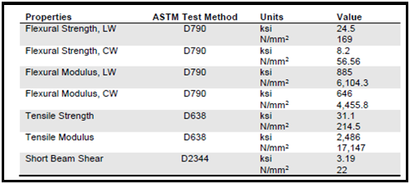

4. Fiberglass panels shall be COMPOSOLITE® as distributed by GEF Incorporated.
B. Connections

1. Panels utilize integrally molded longitudinal grooves into which a connector or toggle is inserted during assembly.

2. 3-way and 45º connectors are utilized in the system to develop corners and facilitate joining walls and sides.

- Toggles are utilized to lock panels and connectors.
- Toggles are utilized to lock panels and connectors.
4. For permanent structures, adhesives are applied in the small grooves along the length of the panel. Toggles mechanically secure components (panels and connectors) and create even pressure until adhesive is cured.
C. Approved Fabricators
1. GEF Incorporated (304)755-1600 www.gefinc.com
2.09 FRP PLANKS:
A. General
1. FRP planks shall be shipped from the manufacturer, palletized and banded with exposed edges protected to prevent damage in shipment.
2. Each piece shall be clearly marked showing manufacturer’s applicable drawing number.
3. FRP planks shall be SAFPLANK® distributed by GEF Incorporated.
B. Design
1. FRP planks shall be 2” (50.8 mm) deep and be capable of withstanding a uniform load of 100 PSF (4.79 kN/m) or a concentrated load of 300 lbs. (1.33 kN) on an area of 4 sq. inches (25.8 cm²) located in the center of the plank with a deflection of no more than 0.25” (6.4 mm).
2. The top surface of all panels shall have a non-skid grit.
3. Panels shall be fabricated to the sizes shown on the drawings.
4. Hold down clamps shall be surface mounted type 316L stainless steel. A minimum of two (2) each per panel. - or -
Hold down clamps shall be type 316L stainless steel insert hold downs as provided by GEF Incorporated. A minimum of two (2) each per panel.
- Color shall be slate gray.

C. Products
1. The FRP planks shall be manufactured by the pultrusion process. The planks shall be 2” (50.8 mm) deep and ______ (select 12” (304.8 mm) or 24” (609.6 mm)) wide with interlocking joints on outside legs of plank. The glass fiber reinforcement for the planks shall be a core of continuous glass strand rovings wrapped with continuous strand glass mat. A synthetic surface veil shall be the outermost layer covering the exterior surfaces.
2. Fiberglass planks shall be made from a fire retardant (select isophthalic polyester or vinyl ester) resin system that meets the flame spread rating of 25 or less in accordance with ASTM E-84, flammability characteristics of UL 94 V0 and meets the self- extinguishing requirements of ASTM D635. UV inhibitors are added to the resin.
2.10 FRP BAFFLE WALL PANEL
A. Materials
1. Each baffle panel shall be manufactured by the pultrusion process utilizing polyester resin to ANSI/NSF standard 61 certified for potable water applications (as required). A synthetic surface veil shall be the outermost layer covering the exterior surface.
2. Baffle Wall Panels shall possess the following typical coupon properties:
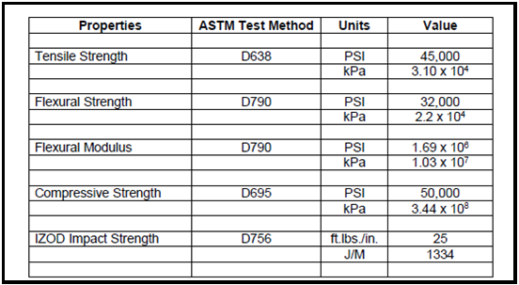

- Baffle Wall Panels shall be distributed by GEF Incorporated.
B. Design
1. 24" (600 mm) Baffle Wall Panel Design Properties
Ixx = 11.388 in4 or 474 cm4
Modulus of Elasticity = 2.5 x 106 psi or 17.2 x 106 kPa
Moment Capacity = 32,620 in-lb or 3,682 N-m
Stiffness EI = 28.47 x 106 lb-in2

- 24" (600 mm) Baffle Wall Panel Deflection (Static Differential Head of Water)
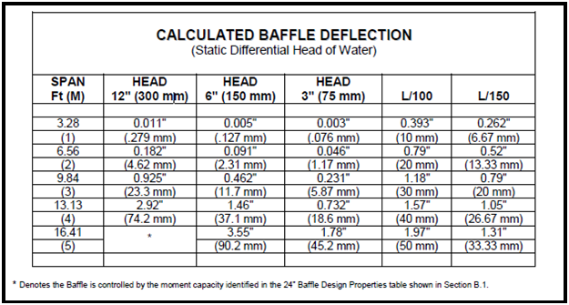

C. Hardware

1. All fasteners, anchors, and structural hardware shall be 316 stainless steel.

2. All connections of Baffle Wall Panels to fiberglass columns or super structure shall be as shown on the approved shop drawings.

D. Approved Fabricators

- GEF Incorporated (304)755-1600 www.gefinc.com

  - MOLDED GRATING AND TREADS:

E. General

- Grating shall be DURAGRATE® as distributed by GEF Incorporated.

F. Design

3. The grating shall be one piece construction with the tops of the bearing bars and cross bars in the same plane.

4. The mesh pattern and thickness shall be:

a. 3/4” (19.1 mm) square mesh, 1-1/2” (38.1 mm) thick
b. 1-1/2” (38.1 mm) square mesh, 1” (25.4 mm) thick
c. 1-1/2” (38.1 mm) square mesh, 1-1/2” (38.1 mm) thick
d. 2” (50.8 mm) square mesh, 2” (50.8 mm) thick
e. 1” (25.4 mm) x 4” (101.6 mm) rectangular mesh, 1” (25.4 mm) thick
f. 1-1/2” (38.1 mm) x 6” (152.4 mm) rectangular mesh, 1-1/2” (38.1 mm) thick

- The standard resin systems and colors are:

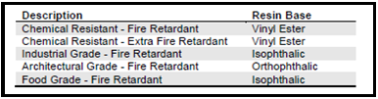

a. The resin used in the manufacture of the grating shall be _____ (select from the table above).

b. The color shall be _____ (chosen from manufacturer’s standard colors).

6. Grating (exclusive of food grade) shall be fire retardant with a flame spread rating of 25 or less when tested in accordance with ASTM E- 84. Food grade grating shall be fire retardant with a flame spread rating of 30 or less when tested in accordance with ASTM E-84.

7. For slip resistance, the top of each bar shall:

a. be manufactured with a meniscus or concave profile - or -
b. have sand or quartz grit applied

G. Products

1. The FRP molded grating and treads shall be manufactured by the open mold process.

2. Molded stairtreads shall be 1-1/2” (38.1 mm) thick in a 1-1/2” (38.1 mm) x 6” (152.4 mm) rectangular mesh pattern. The resin system will be the same as the molded grating or ________ (select vinyl ester, polyester, isophthalic or orthophthalic). The stairtread shall come complete with anti-slip nosing.

3. Hold down clamps shall be:

a. Type M clips for attaching grating to supports – or-
b. Type J clips for attaching grating to supports for moderate loads

4. Grating with cover plate

a. Grating shall be the same as described above in this section.

b. The cover plate for molded grating shall be an integrally molded plate as manufactured by Strongwell.

c. The integrally molded plate may use the same resin as the grating.

d. The integrally molded plate shall be bonded to the grating, and a non-skid grit shall be affixed to the top surface of the assembly.

5. If required, all cut and machined edges, holes and abrasions shall be sealed with a compatible resin.

6. All panels shall be fabricated to the sizes shown on the approved shop drawing.

PART 3 – EXECUTION

3.01 PREPARATION:

- Coordinate and furnish anchorages, setting drawings, diagrams, templates, instructions and directions for installation of anchorages, including concrete inserts, sleeves, anchor bolts and miscellaneous items having integral anchors that are to be embedded in concrete or masonry construction. Coordinate delivery of such items to project site.

- Set sleeves in concrete with tops flush with finish surface elevations; protect sleeves from infiltration of water and debris.

3.02 INSPECTION AND TESTING:

A. The Design Engineer shall have the right to inspect and test all materials to be furnished under these specifications prior to their shipment from the point of manufacture.

B. All labor, power, materials, equipment and appurtenances required for testing shall be furnished by the Contractor at no cost to the Owner.

3.03 INSTALLATION, GENERAL:

A. Fastening to in-place construction: Provide anchorage devices and fasteners where necessary for securing miscellaneous FRP fabrications to in-place construction; include threaded fasteners for concrete and masonry inserts, toggle bolts, through-bolts, lag bolts and other connectors as determined by the Design Engineer.

B. Cutting, fitting and placement: Perform cutting, drilling and fitting required for installation of miscellaneous FRP fabrications. Set FRP fabrication accurately in location, alignment and elevation; with edges and surfaces level, plumb, true and free of rack; measured from established lines and levels.

C. Provide temporary bracing or anchors in form work for items that are to be built into concrete masonry or similar construction.

3.04 ALL FRP INSTALLATION:

A. If required, all field cut and drilled edges, holes and abrasions shall be sealed with a catalyzed resin compatible with the original resin as recommended by the manufacturer.

B. Install items specified as indicated and in accordance with manufacturer’s
instructions.

End of Section 06600

